**Who am I…**

Singaporean Chinese;

Bachelor in Software Engineering;

Ability to speak /read/write for both English and Mandarin;

Non-stop working for 3 employers until today;

* Mentor Media
* HP
* FTDI

Working & living Experiences in 3 different countries and 17 cities：

* China 8 years (Manufacturing Process Engineer & Engineering Manager)；
* Singapore 8 years ( IT Project Manager);
* USA 3 years ( IT /Engineering Team Lead);

**What I have done before…**

Lead global IT/Engineering/BI Team;

Familiar with all manufacturing, warehouse, logistic process ;

Manage lean 6 sigma OEM IT projects over 10+ years;

Experienced HP reorganization, (SAP, B2B and CRM data splitting)

Deal With ODM Foxconn, Quanta, Celestica on manufacturing or logistic process;

Used to Work with ST, HSBC, OCBC bank on B2B/B2Bi IT project system integration;

Used to Work on Production Intelligent line design and AI system integration;

Used to work on the Auto Pick&Pack WMS (AGV Solution);

System Architect with coding capability(Hands on experiences);

* Individual completed coding More than:
  + - * 20 factory shopfloor systems (VB +SQL);
      * 20 web portals (PHP + Linux +MYSQL+ Apache, Django);
      * 50 business intelligent reports (Excel VBA+SQL);
      * 30 python + Shell Scripting for server user or data collection;
* Good knowledge with Software development SDLC & Agile methodology
* IT or manufacturing hardware setup, configuration & maintenance:

Working on the SAP system integration with B2B portal and WMS system;

**What I am looking for…**

* An IT related job with clear direction, more challenge and market rate salary;
* Singapore or overseas working;

**【Basic Info.】**

Name: **ZHANG MINGWEI** Gender: **Male**

Email: **mwzhang@outlook.com** Mobile: **65-97998378**

Birth: **21-July-1979** Race: **Chinese**

Nationality: **Singapore Citizen /H1B1**

Digital CV: <http://www.mwzhang.me>

Personal Blog: <http://mwzhang.blogspot.com/>

Link In: <https://www.linkedin.com/in/mingwei-zhang-b911b4107/>

Github: <https://github.com/ilovezmw>

**【Education.】**

**Year 2015 Bachelor Oxford Brookes University**

* BACHELOR OF SCIENCE (HONS) IN INFORMATION SYSTEMS AND SOFTWARE ENGINEERING
* Grade B/2nd Class Upper

**Year 2003 Diploma Singapore NanYang Polytechnic School**

* Diploma In Manufacturing Engineering
* Specialized in Automation System Design and Plastic Module Design
* Participate the Singapore Robotic Games (Y2003), independently working on Sumo Robot design
* Nanyang Polytechnic Chinese Culture club

**【Professional Experience.】**

**Y2018 (Aug) – Now FTDI Singapore**

* IT/SAP/BI Manager (Lead 6 countries UK, US, CN, TW, SG, VN);
* Report to Engineering Director and COO Directly;
* Overall IT infrastructure & Security & ISO Audit & operation support;
* IT System integration;
* B2B / EDI order integration
* SAP/BO system process;
* Business intelligent system design and setup (Reporting, Sales Report, Production Report, Inventory Report, Aging Report, CRM management);
* SAP B1 integration with WMS;
* SAP HMRC (UK Government Tax system integration)
* Architecture Design Product traceability system design(Warranty Card System) ;
* Factory Shopfloor System design;

**Y2017 (Apr) - Y2018 (Aug) Mentor Media USA (California)**



* IT/Engineering Lead (Tech Lead);
* 3PL Project Management (manufacturing in China and fulfill in USA , Provide System Integration with DHL or UPS/Support /Onboarding);
* Project Manager role in Warehouse Management System Design, Testing & Implementation;
* HP Battery Recall Program (Process Map);
* Dell PPID and Media Support Process (Label Design, automation and all barcode related equipment setup);
* Amazon/shopify system integration with WMS (load order in WMS system using Python or Shell scripting);
* BOSE Refurbish / Testing system and Process design (Sound Testing Process design, label design, automation, testing script, Production line balancing, Time study);
* MS USB Cloning process (Linux Shell scripting);
* IT Security Audit from Microsoft and OEM, all passed successfully;
* Inventory Reporting (VBA report and MSSQL)
* AGV System research and design complete flow;
* Report to regional VP directly;

**Y2011 (Jul) - Y2017 (Feb) HP (Hewlett-Packard) Asia Singapore**

* Manager II (SME in Customer Master Data);
* SAP CRM Master Data Project related
* Data scrubbing and business intelligent reporting
* OTO, OTC(Opportunity To Order, Order To Cash) SME;
* SAP Order Support, Scripting auto load order or batch update order information (VBS);
* Involve HP Split project, Project manager ;
* SMO Project (Company Split IT management experience)

----------------------HP Split(SMO)-----------------

* Focus B2B and B2Bi system integration (new customer onboard, customer like M1, Shell, Work with IT to make sure entire order flow pass through and Project sign off);
* Take lead to talk to customer understand customer system and provide solution (Project timeline, schedule and guide IT);
* Sales Process Map and training (HP B2B Portal, B2Bi Portal) ;
* All related IT Green Belt Project;

**Y2003- Y211 (Jun) Mentor Media Singapore & China (Shanghai, Suzhou, Wuhan, Shenzhen, Chongqing, Tianjin, Yantai, Xiamen)**

* Manufacturing Process Engineer ;
* Training in Singapore for Microsoft Licensing and HP CPMO project related
* Production system support (Shopfloor, ERP);
* IT System Analysis (SQL/VB system Order status, inventory query);
* SQL/VBA report Coding (inventory report, aging report, shipment report, backlog report, etc);
* Manufacturing hardware support , barcode scanner, Zebra printer integration

**Year 2007 onwards:**

* Principle Engineering for great China;
* New Branch Planning & Setup (Successfully setup the HP Xiyong processing zone);
* Involve HP Project bidding (IT system architect and budgeting);
* Work in Wuhan Foxcornn for Microsoft co-location project. Setup the MS licensing server and entire MS licensing printing equipment;
* Fast fulfillment IT system integration(4 hour TAT, 24hours X 7 days, no any escalation over 8 years);
* CTO type Inventory management (include the professional stock ticket) ;
* Intelligent Production Line Design (Vision System & Barcode scanning & auto weighing system );
* Warehouse Management (Deployment for Tianjin and Shenzhen, Basic pick and pack setup )
* Supplier and contractor management;
* Propose new tech or solution to management for cost saving;

**【Skillset Self-Evaluation】**

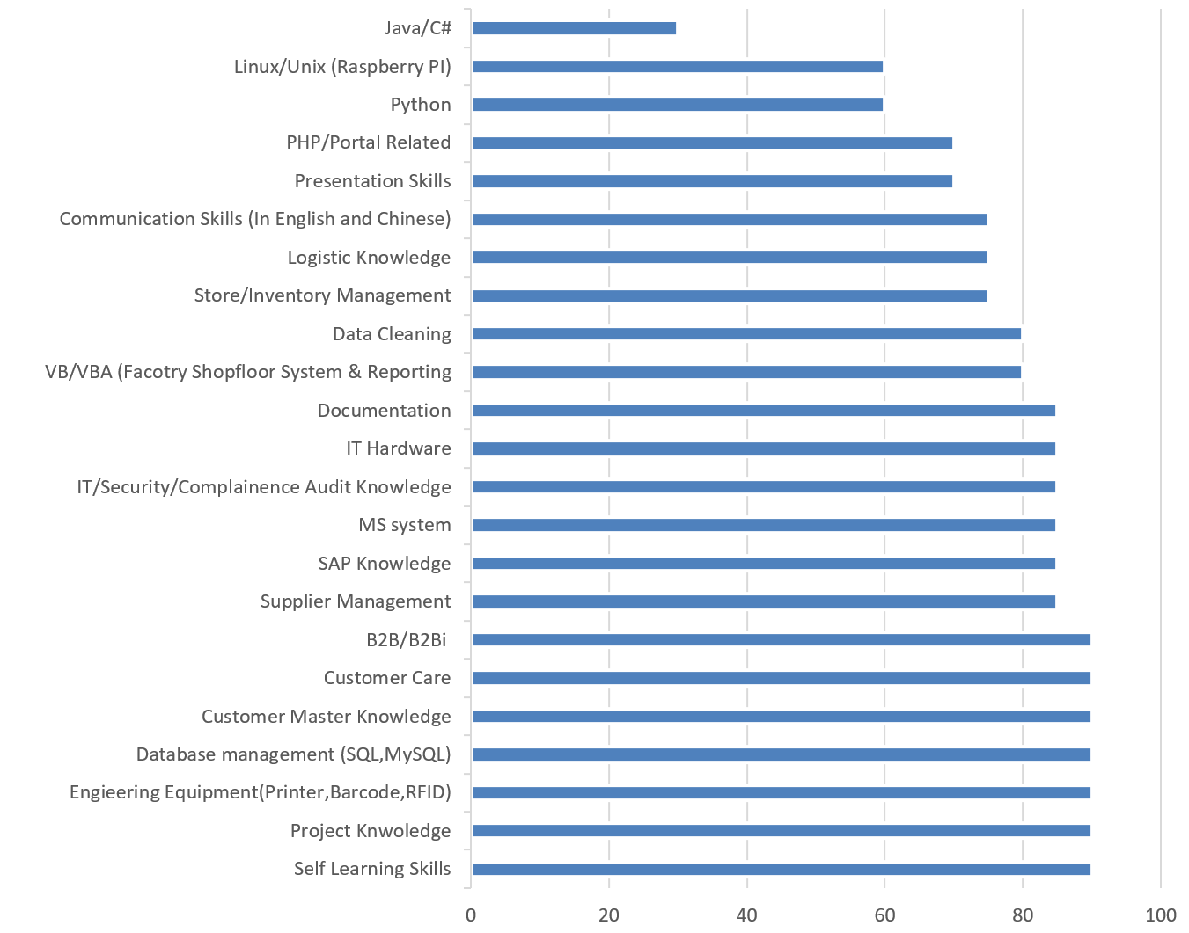

------END FOR NOW------